Business Logic
# Source: AI Source: Provided by: [Data Path: Persons Table -> ID Column: 1, Name_En Column: Motasem Essam] -> From: [Chatgpt (GPT‑5 Mini)] on [12/9/2025]
Business Logic represents the rules and operations that reflect real-world business requirements.
It defines how the system behaves according to business needs.
👉 It answers the question:
“What rules does the business want the system to follow?”

🔑 Key Idea
# Source: AI Source: Provided by: [Data Path: Persons Table -> ID Column: 1, Name_En Column: Motasem Essam] -> From: [Chatgpt (GPT‑5 Mini)] on [12/9/2025]
Business logic = real-world rules translated into code

🧩 Simple Example
# Source: AI Source: Provided by: [Data Path: Persons Table -> ID Column: 1, Name_En Column: Motasem Essam] -> From: [Chatgpt (GPT‑5 Mini)] on [12/9/2025]
👉 Real-world rule:
“If order total > 100 → apply 10% discount”
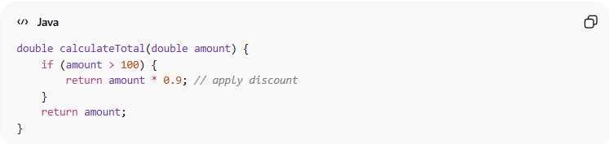
double calculateTotal(double amount) {
if (amount > 100) {
return amount * 0.9; // apply discount
}
return amount;
}

🧱 Where Business Logic Lives
# Source: AI Source: Provided by: [Data Path: Persons Table -> ID Column: 1, Name_En Column: Motasem Essam] -> From: [Chatgpt (GPT‑5 Mini)] on [12/9/2025]
- Usually in the Service Layer
- Sometimes in Domain Models (DDD)
Controller → Service (Business Logic) → Repository → Database

❌ Bad Example (Business Logic in Wrong Place)
# Source: AI Source: Provided by: [Data Path: Persons Table -> ID Column: 1, Name_En Column: Motasem Essam] -> From: [Chatgpt (GPT‑5 Mini)] on [12/9/2025]
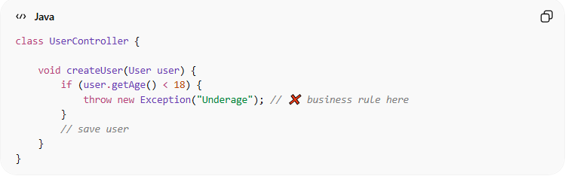
class UserController {

void createUser(User user) {
if (user.getAge() < 18) {
throw new Exception("Underage"); // ❌ business rule here
}
// save user
}
}
👉 Problem:
- Logic is in controller instead of service

✅ Good Example (Proper Business Logic Placement)
# Source: AI Source: Provided by: [Data Path: Persons Table -> ID Column: 1, Name_En Column: Motasem Essam] -> From: [Chatgpt (GPT‑5 Mini)] on [12/9/2025]
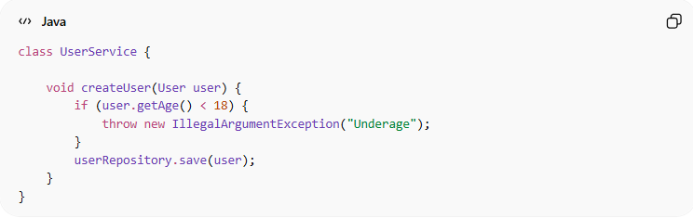
class UserService {

void createUser(User user) {
if (user.getAge() < 18) {
throw new IllegalArgumentException("Underage");
}
userRepository.save(user);
}
}
👉 Benefits:
- Clear separation of concerns
- Easier to test and maintain

🧩 More Examples of Business Logic

1️⃣ E-commerce
# Source: AI Source: Provided by: [Data Path: Persons Table -> ID Column: 1, Name_En Column: Motasem Essam] -> From: [Chatgpt (GPT‑5 Mini)] on [12/9/2025]
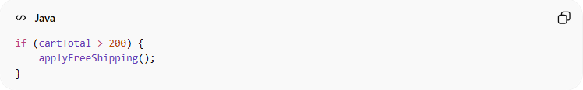
if (cartTotal > 200) {
applyFreeShipping();
}

2️⃣ Banking
# Source: AI Source: Provided by: [Data Path: Persons Table -> ID Column: 1, Name_En Column: Motasem Essam] -> From: [Chatgpt (GPT‑5 Mini)] on [12/9/2025]
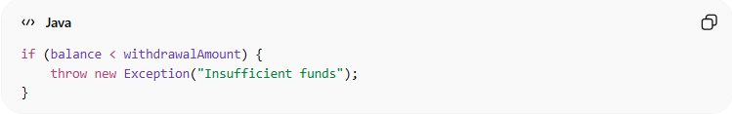
if (balance < withdrawalAmount) {
throw new Exception("Insufficient funds");
}

3️⃣ Authentication
# Source: AI Source: Provided by: [Data Path: Persons Table -> ID Column: 1, Name_En Column: Motasem Essam] -> From: [Chatgpt (GPT‑5 Mini)] on [12/9/2025]
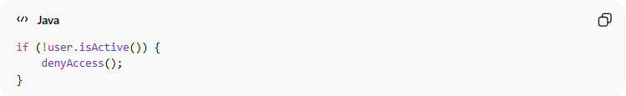
if (!user.isActive()) {
denyAccess();
}

💡 Best Practices
# Source: AI Source: Provided by: [Data Path: Persons Table -> ID Column: 1, Name_En Column: Motasem Essam] -> From: [Chatgpt (GPT‑5 Mini)] on [12/9/2025]
- Keep business logic separate from UI and database code
- Make it clear and readable
- Use meaningful names
- Keep it testable and reusable

🚫 Common Mistakes
# Source: AI Source: Provided by: [Data Path: Persons Table -> ID Column: 1, Name_En Column: Motasem Essam] -> From: [Chatgpt (GPT‑5 Mini)] on [12/9/2025]
- Mixing business logic with controllers or UI
- Writing unclear or hardcoded rules
- Duplicating business rules in multiple places

🧾 Summary
# Source: AI Source: Provided by: [Data Path: Persons Table -> ID Column: 1, Name_En Column: Motasem Essam] -> From: [Chatgpt (GPT‑5 Mini)] on [12/9/2025]
Business logic helps you:
- Implement real-world rules in code
- Control how the system behaves
- Keep your application consistent and correct

